Step 1:

Cloned Karate project from github.

Step 2:

Commented “@RunWith” in TestBase class.

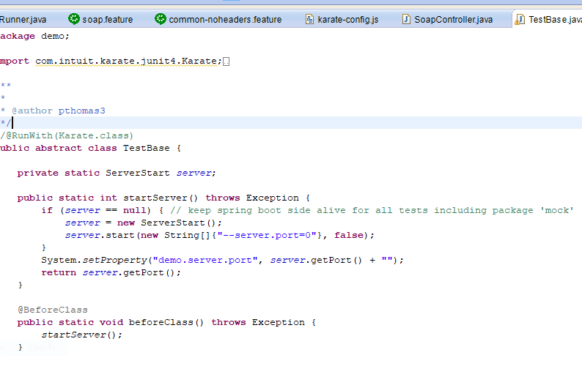

Step 3:

Downloaded “[Cucumber-Eclipse plugin](https://cucumber.io/cucumber-eclipse/)” as stated in below.

https://github.com/intuit/karate#eclipse-quickstart

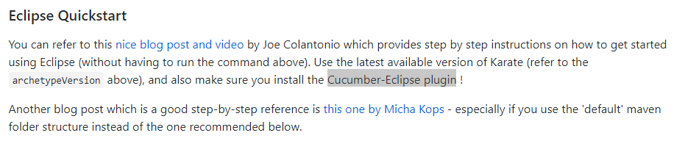

Step 4:

Created new sample.feature file.

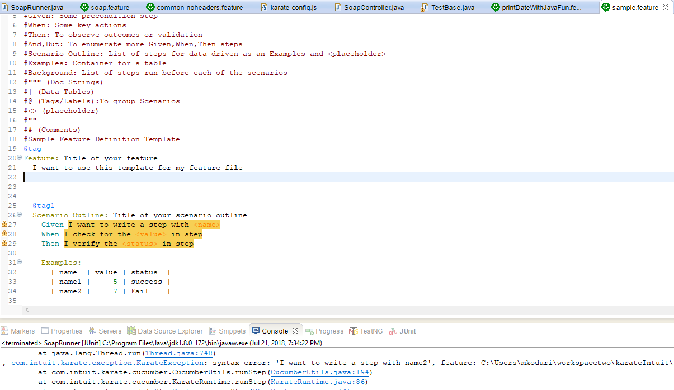

Step 5:

My Runner class

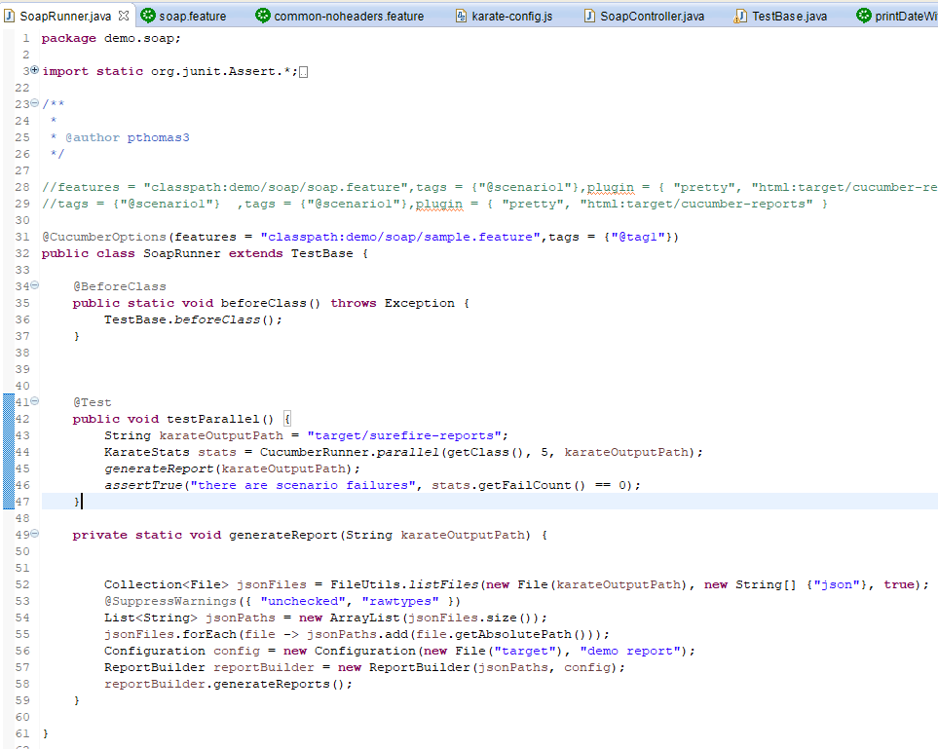

Step 6:

Run as:

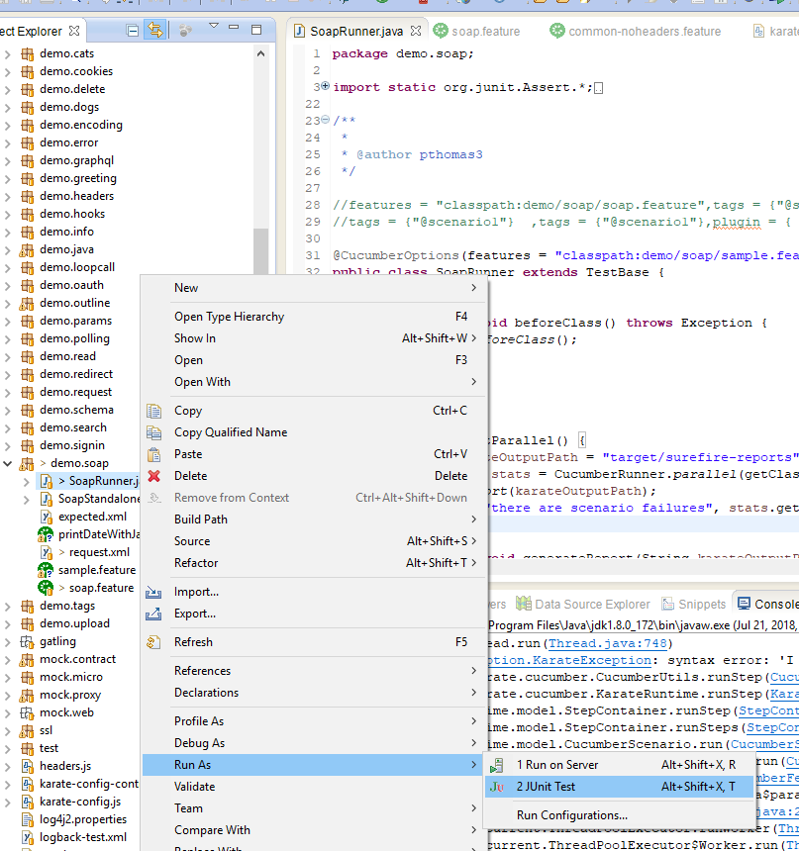

Step 7:

Navigated to “C:\Users\userfolder\workspacetwo\karateIntuit\karate\karate-demo\target\cucumber-html-reports”

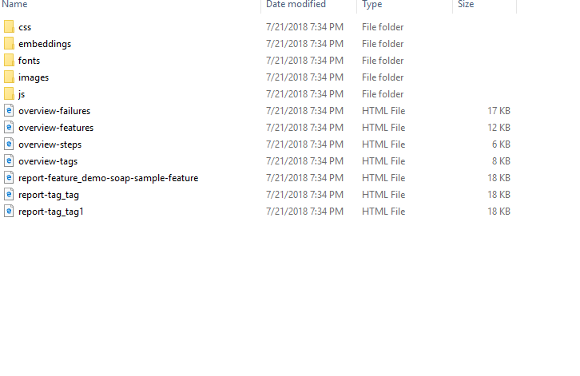

Step 8:

Result:

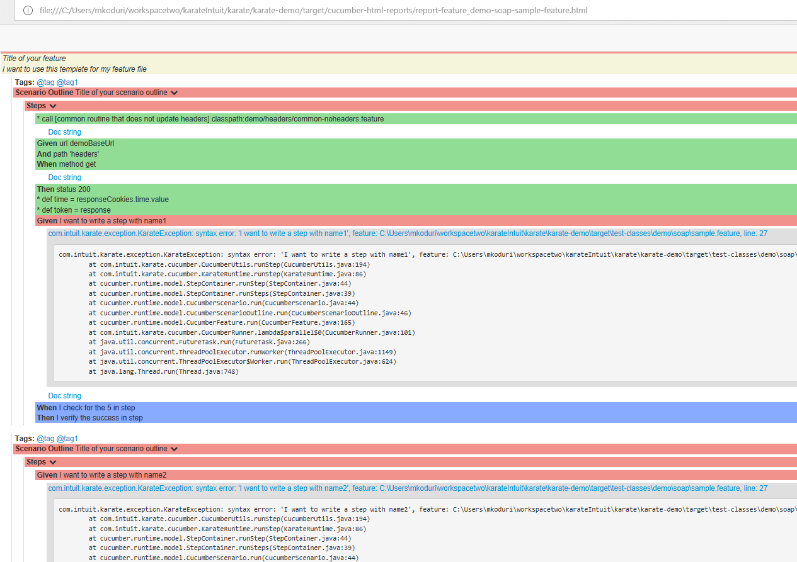

Step 9:

NOTE: I didn’t bother about the “common-nodeahers.feature”.

My issue I with sample.feature.

As you can see all I am doing is running the one feature file.

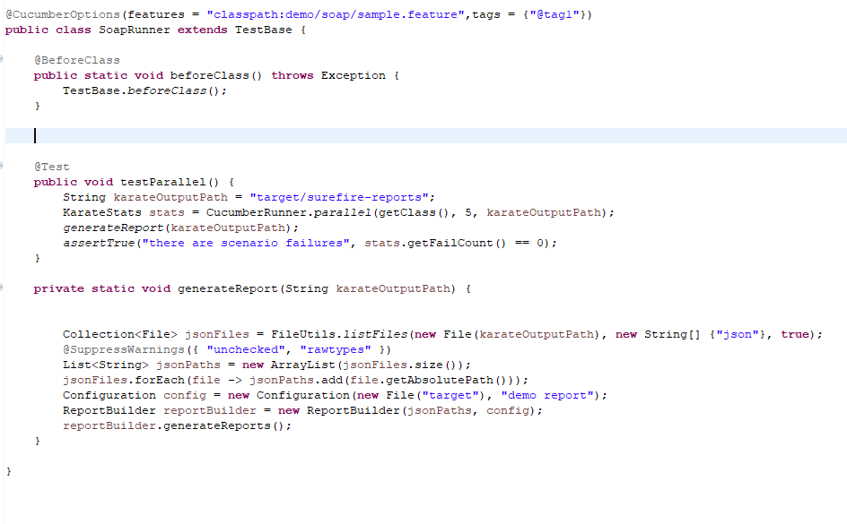

Issue:

I tried different ways with data.

In other words I have used;

@tag1

Scenario Outline: Title of your scenario outline

Given I want to write a step with <name>

When I check for the <value> in step

Then I verify the <status> in step

Examples:

| name | value | status |

| name1 | 5 | success |

| name2 | 7 | Fail |

But I get KarateException with syntac error.

Then I also tried,

@tag1

Scenario Outline: Title of your scenario outline

Given I want to write a step with “<name>”

When I check for the “<value>” in step

Then I verify the “<status>” in step

Examples:

| name | value | status |

| name1 | 5 | success |

| name2 | 7 | Fail |

I tried lot different ways, but I still get the exception. As stated above.

Can someone help me understand the issue.